The User Registration Help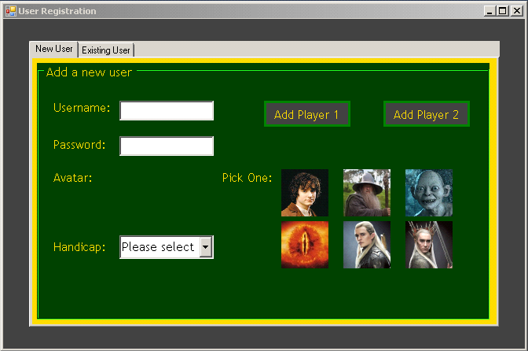

This is the user registration screen when you want to create a new user.
You must enter your chosen
- Username (which must be at least 3 characters long),
- Password (which must be at least 8 characters long),
- Pick an avatar
- Select a handicap.
This is the user registration screen when you want to select your user’s profile/existing user. It is selected by selecting the tab at the top of the screen.

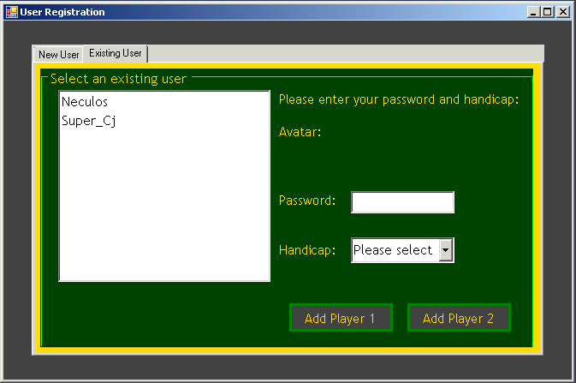
Existing users must select their username. This will bring up your avatar.
To continue, you must enter your password and select a handicap.
After this, clicking on one of the buttons will add your user to the game.
After the other player has entered their details on either tab the game will begin.

Handicap:
The handicap system gives you the option to give yourself an easier or more difficult fight against your opponent. If you wish to have your units at maximum health and damage (recommended for new players) set the handicap to 100%.
At 90% your units will only have 90% of their maximum damage and health. At 80% they have 80% of their maximum damage and health etc.
Both players must set their handicap. If one player is new to the game and the second is well versed in the game and wants to give the new user an advantage, the second user would set his handicap lower than the new user.

